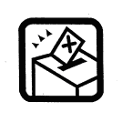

School/College Council Election
NOTICE OF POLL

Date of Election:
Time of Polling:

Location of Polling Station(s):

Candidates
Name | Party or Independent

Issued by the Election Coordinator

