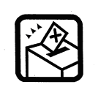
OFFICIAL POLL CARD
Please read the reverse of this card carefully to find out how to make your vote count.

Your Name: School:

Your Registration Number:

Polling Day: Polling Hours:

Polling Station:

OFFICIAL POLL CARD
Please read the reverse of this card carefully to find out how to make your vote count.

Your Name: School:

Your Registration Number:

Polling Day: Polling Hours:

Polling Station:

