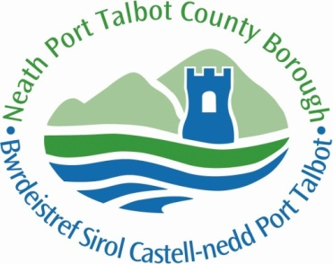

Neath Port Talbot Educational Psychology Service:

Recommendations for

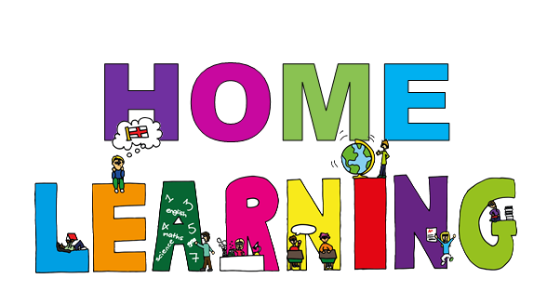

(With accreditations to: Blaenau Gwent, Monmouthshire and Cornwall EPS and the Department for Education)

This booklet contains advice for parents and carers who may find themselves looking for ideas to support children’s learning at home. Also included is a list of useful, free educational resources for different ages and subjects. However, these should not be used in place of existing resources which schools may be using as part of their continued provision for pupils’ education at this time. This list of resources is not exhaustive and there are many other resources available to families.



Please also visit the ‘NPT Education Inclusion Service’ Facebook page for further ideas with websites, ideas and links being added regularly.

Please don’t feel pressured into re-creating school at home. Having your own structure and routine for learning and play can be beneficial but there’s no need to follow a school timetable unless that suits you. Home schooling is challenging. Be kind and go easy on yourself and your children - just do what you can in these difficult and uncertain times. For the most part, children will need what they’ve always needed; love, attention and opportunities to learn and play.

|  |  |
| --- | --- |
| **Key Stage** | **Age Equivalent** |
| Early Years | < 5 years |
| Foundation Phase | 5-7 years |
| Key Stage 2 | 7-11 years |
| Key Stage 3 | 11-14 years |
| Key Stage 4 | 14-16 years |
| Key Stage 5 | 16-18 years |

For your reference:

Hints and Tips

Try and keep to a **structure and routine** that suits you, even if this is just keeping bedtime and morning routines and set mealtimes. Encouraging children to get up and dressed during the week helps maintain some difference between weekdays and weekends; promoting a sense of normality that children will find reassuring.

Keep **boundaries** firm and make it clear that you expect the same standards of behaviour as usual. Boundaries show children that adults are still in control and taking care of them, which helps children to feel safe.

Expect children to do **some learning every day**. In the longer-term schools are likely to provide opportunities for online learning. In the short term, or as extra activities there are a wealth of helpful websites (see pages included in this booklet), many of which they will be able to access independently. Continuing with their learning helps promote a sense of normality and purpose as well as keeping them up to date for when they are back at school.

Establish **guidelines for screen time** (e.g. computers, consoles, tablets and TV) and try and balance this with other fun activities (e.g. board games, card games, tying shoe laces, juggling, baking). Older children might want to set their own goals. Encourage children to help with household chores – they are still learning life skills!

**Follow your child’s lead** for things that they would like to learn about – if they are motivated they will learn a lot more.

**Independence is important** – children need to learn through experimentation and practise.

Make sure that children get some time to engage in physical activity and **burn off energy** every day. Younger children will enjoy assault courses, discos etc. Older children and teens might respond better to fitness videos.

Find **opportunities for them to interact** with their friends remotely. For young people, contact with their peers is especially important. Technology provides lots of opportunities for older children to connect, chat and game together. But be wary of giving unsupervised access to platforms that you would not normally allow your child onto; the internet still poses the same risks as in normal times.

Give children **opportunities to have a say** in what will be happening. They may have had a lot of their freedoms and choices removed for a while and may feel powerless or angry. They are more likely to ‘buy in’ to new rules and routines if they feel that they have a voice. Family meetings where children and adults problem-solve together can be helpful for this. (<https://bristolchildparentsupport.co.uk/ready-family-meetings/>)

Below is an example timetable. It has been included as a guide but may be helpful in terms of thinking about how to maintain some structure and routine throughout days at home. Remember to intersperse activities with breaks, and don’t forget healthy snacks and drinks!



General Learning

**BBC Bitesize.** Learning and revision materials for primary, secondary and post-16 pupils. As of Monday 20 April, BBC Bitesize will publish daily online lessons for all ages. They'll also have a new dedicated TV channel full of learning content, podcasts on BBC Sounds and loads of educational videos on iPlayer. <https://www.bbc.co.uk/bitesize/>

**BrainPOP.** Free access during school closures. Offers animated videos on a variety of subjects. <https://www.brainpop.com/>

**Crash Course.** Free educational videos covering a wide range of topics via their YouTube channel. ttps://thecrashcourse.com

**Crash Course Kids.** Free educational videos covering a wide range of topics via their YouTube channel. Aimed at a younger audience. <https://m.youtube.com/user/crashcoursekids>

Crest. Challenging and thought provoking real-world STEM projects for young people of all ages. <https://www.crestawards.org>

**Future Learn.** Free to access 100s of courses, only pay to upgrade if you need a certificate in your name (own account from age 14+ but younger learners can use a parent account). <https://www.futurelearn.com>

**Khan Academy**. Different apps for different aged pupils on a range of different subjects (uses American pronunciation and spellings). https://www.khanacademy.org

**National Geographic Kids.** Resources, games and quizzes covering a range of topics, aimed at primary aged children. https://www.natgeokids.com/uk/

**Nature Detectives.** Discover free resources and inspire pupils with outdoor learning. Aimed at primary aged children.https://www.woodlandtrust.org.uk/blog/2020/03/nature-detectives/

**Oxford Owl for Home.** Free educational resources for primary aged children. <https://www.oxfordowl.co.uk/for-home/>

**Ted Ed@Home.** TED-Ed is working with expert educators and TED speakers throughout the world to create and share high-quality, interactive, video-based lessons on a daily basis, for free (registration required). Get lesson plans organized by age group that span all subjects delivered to your inbox every day. <https://ed.ted.com/daily_newsletter>

**The Kids Should See This**. Smart educational videos for curious minds of all ages. <https://thekidshouldseethis.com>

**The Big History Project.** A joint effort between teachers, scholars, scientists, and their supporters to bring a multi-disciplinary approach to knowledge to lifelong learners around the world. Aimed at secondary aged students. <https://www.bighistoryproject.com/home>

**Twinkl.** This is more for printouts, and usually at a fee, but they are offering a month of free access to parents in the event of school closures. Use code PARENTTWINKLHELPS. <https://www.twinkl.co.uk>

English

Early Years

**Audible.** All children’s audiobooks are available for free while schools are closed. <https://stories.audible.com/start-listen>

**Authorfy**. Access to masterclasses on texts from a range of authors, including videos from the authors and activities linked to novels (registration required). [https://authorfy.com](https://authorfy.com/)

**Book Trust.** A site with recommended booklists, categorised by age range and topic, including fiction and non-fiction. Family activities are included in the ‘Home Time’ section. <https://www.booktrust.org.uk/books-and-reading/bookfinder/>

**Classroom Secrets.** Downloadable resource packs which cover a range of subjects, including reading and writing. <https://classroomsecrets.co.uk/free-home-learning-packs/>

**Love Reading 4 Kids.** A site with recommended booklists, categorised by age range and topic, covering fiction and non-fiction. <https://www.lovereading4kids.co.uk/>

**Purple Mash**. Free during the school closure period. Each week, a selection of daily activities is produced on different subjects, including comprehension and grammar (registration required). <https://2simple.com/purple-mash/>

**Speed Sounds Lessons.** Short Speed Sounds lessons for children to watch at home every weekday on YouTube. Each lesson is ten minutes long and available for 24 hours. <https://www.youtube.com/channel/UCo7fbLgY2oA_cFCIg9GdxtQ>

**Story Time with Nick**. Available from Monday 20 April. Films of well-loved stories read by Nick Cannon, a trained actor, teacher and trainer. <https://www.ruthmiskin.com/en/find-out-more/help-during-school-closure/>

**The Children’s Poetry Archive.** An archive of spoken poetry recordings. Children can listen to poems read out loud. <https://childrens.poetryarchive.org/>

Key Stage 1

**Audible.** All children’s audiobooks are available for free while schools are closed. <https://stories.audible.com/start-listen>

**Authorfy**. Access to masterclasses on texts from a range of authors, including videos from the authors and activities linked to novels (registration required). [https://authorfy.com](https://authorfy.com/)

**Book Trust.** A site with recommended booklists, categorised by age range and topic, including fiction and non-fiction. Family activities are included in the ‘Home Time’ section. <https://www.booktrust.org.uk/books-and-reading/bookfinder/>

**Classroom Secrets.** Downloadable resource packs which cover a range of subjects, including reading and writing. <https://classroomsecrets.co.uk/free-home-learning-packs/>

**English Mastery.** Downloadable resource books providing 8 weeks of activities. <https://www.englishmastery.org/>

**Literacy Shed.** Downloadable resource packs with tasks based on video clips on YouTube. <https://www.literacyshedplus.com/en-gb/browse/free-resources/key-stage-2-activity-packs>

**Love Reading 4 Kids.** A site with recommended booklists, categorised by age range and topic, covering fiction and non-fiction. <https://www.lovereading4kids.co.uk/>

**Pobble 365.** A new image is published each day as a basis for creative writing. Story starters, questions and drawing ideas are provided. <https://www.pobble365.com/>

**Purple Mash**. Free during the school closure period. Each week, a selection of daily activities is produced on different subjects, including comprehension and grammar (registration required). <https://2simple.com/purple-mash/>

**Speed Sounds Lessons.** Short Speed Sounds lessons for children to watch at home every weekday on YouTube. Each lesson is ten minutes long and available for 24 hours. <https://www.youtube.com/channel/UCo7fbLgY2oA_cFCIg9GdxtQ>

**Story Time with Nick**. Available from Monday 20 April. Films of well-loved stories read by Nick Cannon, a trained actor, teacher and trainer. <https://www.ruthmiskin.com/en/find-out-more/help-during-school-closure/>

**Teach Your Monster to Read.** Covers everything from letters and sounds to reading full sentences (registration required). <https://www.teachyourmonstertoread.com/>

**The Children’s Poetry Archive.** An archive of spoken poetry recordings. Children can listen to poems read out loud. <https://childrens.poetryarchive.org/>

**The Day Newsletter.** A daily newsletter for parents and carers at home with children, helping to enrich learning with real-world knowledge and skills (registration required). <https://theday.co.uk/subscriptions/the-day-home>

Key Stage 2

**Audible.** All children’s audiobooks are available for free while schools are closed. <https://stories.audible.com/start-listen>

**Authorfy**. Access to masterclasses on texts from a range of authors, including videos from the authors and activities linked to novels (registration required). [https://authorfy.com](https://authorfy.com/)

**Book Trust.** A site with recommended booklists, categorised by age range and topic, including fiction and non-fiction. Family activities are included in the ‘Home Time’ section. <https://www.booktrust.org.uk/books-and-reading/bookfinder/>

**Classroom Secrets.** Downloadable resource packs which cover a range of subjects, including reading and writing. <https://classroomsecrets.co.uk/free-home-learning-packs/>

**English Mastery.** Downloadable resource books providing 8 weeks of activities. <https://www.englishmastery.org/>

**Literacy Shed.** Downloadable resource packs with tasks based on video clips on YouTube. <https://www.literacyshedplus.com/en-gb/browse/free-resources/key-stage-2-activity-packs>

**Love Reading 4 Kids.** A site with recommended booklists, categorised by age range and topic, covering fiction and non-fiction. <https://www.lovereading4kids.co.uk/>

**Pobble 365.** A new image is published each day as a basis for creative writing. Story starters, questions and drawing ideas are provided. <https://www.pobble365.com/>

**Poetry by Heart.** A wide selection of poetry covering different topics (registration not required to view poems, but it is required to access teaching resources). <https://www.poetrybyheart.org.uk/>

**Purple Mash**. Free during the school closure period. Each week, a selection of daily activities is produced on different subjects, including comprehension and grammar (registration required). <https://2simple.com/purple-mash/>

**Speed Sounds Lessons.** Short Speed Sounds lessons for children to watch at home every weekday on YouTube. Each lesson is ten minutes long and available for 24 hours. <https://www.youtube.com/channel/UCo7fbLgY2oA_cFCIg9GdxtQ>

**Story Time with Nick**. Available from Monday 20 April. Films of well-loved stories read by Nick Cannon, a trained actor, teacher and trainer. <https://www.ruthmiskin.com/en/find-out-more/help-during-school-closure/>

**Teach Your Monster to Read.** Covers everything from letters and sounds to reading full sentences (registration required). <https://www.teachyourmonstertoread.com/>

**The Children’s Poetry Archive.** An archive of spoken poetry recordings. Children can listen to poems read out loud. <https://childrens.poetryarchive.org/>

**The Day Newsletter.** A daily newsletter for parents and carers at home with children, helping to enrich learning with real-world knowledge and skills (registration required). <https://theday.co.uk/subscriptions/the-day-home>

Key Stage 3

**Audible.** All children’s audiobooks are available for free while schools are closed. <https://stories.audible.com/start-listen>

**English Mastery.** Downloadable resource books providing 12 weeks of activities covering writing and poetry. <https://www.englishmastery.org/>

**English and Media Centre.** Downloadable resources covering a range of texts for key stage 3. GCSE resources are categorised by examination board. <https://www.englishandmedia.co.uk/publications/>

**Pobble 365.** A new image is published each day as a basis for creative writing. Story starters, questions and drawing ideas are provided. <https://www.pobble365.com/>

**Poetry by Heart.** A wide selection of poetry covering different topics (registration not required to view poems, but it is required to access teaching resources). <https://www.poetrybyheart.org.uk/>

**The Children’s Poetry Archive.** An archive of spoken poetry recordings. Children can listen to poems read out loud. <https://childrens.poetryarchive.org/>

**The Day Newsletter.** A daily newsletter for parents and carers at home with children, helping to enrich learning with real-world knowledge and skills (registration required). <https://theday.co.uk/subscriptions/the-day-home>

Key Stage 4

**Audible.** All children’s audiobooks are available for free while schools are closed. <https://stories.audible.com/start-listen>

**English and Media Centre.** Downloadable resources covering a range of texts for key stage 3. GCSE resources are categorised by examination board. <https://www.englishandmedia.co.uk/publications/>

**Pobble 365.** A new image is published each day as a basis for creative writing. Story starters, questions and drawing ideas are provided. <https://www.pobble365.com/>

**Poetry by Heart.** A wide selection of poetry covering different topics (registration not required to view poems, but it is required to access teaching resources). <https://www.poetrybyheart.org.uk/>

**Seneca**. A range of downloadable resources covering the GCSE curriculum, categorised by examination board. <https://app.senecalearning.com/courses?Price=Free&Age+Group=GCSE&Subject=English+Language>

**The Children’s Poetry Archive.** An archive of spoken poetry recordings. Children can listen to poems read out loud. <https://childrens.poetryarchive.org/>

**The Day Newsletter.** A daily newsletter for parents and carers at home with children, helping to enrich learning with real-world knowledge and skills (registration required). <https://theday.co.uk/subscriptions/the-day-home>

Key Stage 5

**The Day Newsletter.** A daily newsletter for parents and carers at home with children, helping to enrich learning with real-world knowledge and skills (registration required). <https://theday.co.uk/subscriptions/the-day-home>

Maths

Early Years

**Mathematics Mastery.** Downloadable guidance and resource packs for parents and pupils. <https://www.mathematicsmastery.org/free-resources>

**Nrich.** A range of activities. Some are interactive and some are to be completed offline. Activities are categorised by age range. <https://nrich.maths.org/>

**Numberblocks.** Videos for numeracy development designed for children aged 0 to 6. There are fun activities that can be applied to everyday life and play. <https://www.bbc.co.uk/cbeebies/grownups/help-your-child-with-maths>

**White Rose Maths (home learning).** Presentations and downloadable workbooks which are easy to use for parents. New material is being released each week. <https://whiterosemaths.com/homelearning/>

Key Stage 1

**Hamilton Trust (home learning section).** Downloadable resource packs with teacher guidance. A week’s worth of resources is provided for each year group. <https://www.hamilton-trust.org.uk/blog/learning-home-packs/>

**Mathematics Mastery.** Downloadable guidance and resource packs for parents and pupils. <https://www.mathematicsmastery.org/free-resources>

**Nrich.** A range of activities. Some are interactive and some are to be completed offline. Activities are categorised by age range. <https://nrich.maths.org/>

**Numberblocks.** Videos for numeracy development designed for children aged 0 to 6. There are fun activities that can be applied to everyday life and play. <https://www.bbc.co.uk/cbeebies/grownups/help-your-child-with-maths>

**Top Marks**. A range of interactive maths games categorised by age group. <https://www.topmarks.co.uk/maths-games>

**White Rose Maths (home learning).** Presentations and downloadable workbooks which are easy to use for parents. New material is being released each week. <https://whiterosemaths.com/homelearning/>

Key Stage 2

**Hamilton Trust (home learning section).** Downloadable resource packs with teacher guidance. A week’s worth of resources is provided for each year group. <https://www.hamilton-trust.org.uk/blog/learning-home-packs/>

**Mathematics Mastery.** Downloadable guidance and resource packs for parents and pupils. <https://www.mathematicsmastery.org/free-resources>

**Nrich.** A range of activities. Some are interactive and some are to be completed offline. Activities are categorised by age range. <https://nrich.maths.org/>

**Numberblocks.** Videos for numeracy development designed for children aged 0 to 6. There are fun activities that can be applied to everyday life and play. <https://www.bbc.co.uk/cbeebies/grownups/help-your-child-with-maths>

**Top Marks**. A range of interactive maths games categorised by age group. <https://www.topmarks.co.uk/maths-games>

**White Rose Maths (home learning).** Presentations and downloadable workbooks which are easy to use for parents. New material is being released each week. <https://whiterosemaths.com/homelearning/>

Key Stage 3

**Bowland Maths Resources.** Downloadable assessments on a range of subjects, including sample answers and assessment tips. <https://www.bowlandmaths.org.uk/>

**Mathigon**. Interactive maths resources that allow teachers and parents to track student progress and set activities. <https://mathigon.org/>

**Mathematics Mastery.** Downloadable guidance and resource packs for parents and pupils. <https://www.mathematicsmastery.org/free-resources>

**Nrich.** A range of activities. Some are interactive and some are to be completed offline. Activities are categorised by age range. <https://nrich.maths.org/>

**Nrich Core Maths.** Games and puzzles as well as mathematical-thinking and problem-solving questions. Content is categorised by topic and age group. <https://nrich.maths.org/12524>

**Nrich ‘Solving Together’ project.** This is a project that provides activities for parents and carers to try with children. <https://nrich.maths.org/solvingtogether>

**Top Marks**. A range of interactive maths games categorised by age group. <https://www.topmarks.co.uk/maths-games>

**White Rose Maths (home learning).** Presentations and downloadable workbooks which are easy to use for parents. New material is being released each week. <https://whiterosemaths.com/homelearning/>

Key Stage 4

**Bowland Maths Resources.** Downloadable assessments on a range of subjects, including sample answers and assessment tips. <https://www.bowlandmaths.org.uk/>

**Corbett Maths.** A range of videos and downloadable questions categorised by topic and predicted grade. <https://corbettmaths.com/contents/>

**Mathigon**. Interactive maths resources that allow teachers and parents to track student progress and set activities. <https://mathigon.org/>

**Maths Kitchen.** An interactive GCSE revision website. Resources are categorised by topic, including video lessons and practice questions. <https://mathskitchen.com/topics>

**Nrich.** A range of activities. Some are interactive and some are to be completed offline. Activities are categorised by age range. <https://nrich.maths.org/>

**Nrich Core Maths.** Games and puzzles as well as mathematical-thinking and problem-solving questions. Content is categorised by topic and age group. <https://nrich.maths.org/12524>

Key Stage 5

**Nrich Core Maths.** Games and puzzles as well as mathematical-thinking and problem-solving questions. Content is categorised by topic and age group. <https://nrich.maths.org/12524>

**STEP Support Programme**. Offered by the University of Cambridge to help university applicants develop their advanced mathematical problem-solving skills and prepare for STEP mathematics exams. Assessments are downloadable. <https://maths.org/step/welcome>

**Underground Maths**. A range of interactive tasks and questions linked to the A level maths and further maths curriculums. <https://undergroundmathematics.org/>

Science

Key Stage 1

**BBC Bitesize.** Interactive resources covering the primary science curriculum. <https://www.bbc.co.uk/bitesize/primary>

**STEM Learning (home learning).** An online resource bank, which links to resources on external websites. The site features a live chat function offering support from subject experts. New home learning resources are being developed. <https://www.stem.org.uk/primary-science>

Key Stage 2

**BBC Bitesize.** Interactive resources covering the primary science curriculum. <https://www.bbc.co.uk/bitesize/primary>

**STEM Learning (home learning).** An online resource bank, which links to resources on external websites. The site features a live chat function offering support from subject experts. New home learning resources are being developed. <https://www.stem.org.uk/primary-science>

Key Stage 3

**BBC Bitesize**. Interactive resources covering the key stage 3 and key stage 4 science curriculums. Includes separate sections for biology, physics and chemistry. <https://www.bbc.co.uk/bitesize>

**Institute of Physics (IOP).** A set of articles and resources designed to support home-based learning. <https://spark.iop.org/supporting-schools-and-colleges-during-covid-19>

**Royal Society of Chemistry (RSC).** A set of articles and resources designed to support home-based learning. <https://edu.rsc.org/remote-teaching-support>

**STEM Learning (home learning).** An online resource bank, which links to resources on external websites. The site features a live chat function offering support from subject experts. New home learning resources are being developed. <https://www.stem.org.uk/resources/curated-collections/secondary-and-level-science-0>

Key Stage 4

**BBC Bitesize**. Interactive resources covering the key stage 3 and key stage 4 science curriculums. Includes separate sections for biology, physics and chemistry. <https://www.bbc.co.uk/bitesize>

**Institute of Physics (IOP).** A set of articles and resources designed to support home-based learning. <https://spark.iop.org/supporting-schools-and-colleges-during-covid-19>

**Royal Society of Chemistry (RSC).** A set of articles and resources designed to support home-based learning. <https://edu.rsc.org/remote-teaching-support>

**STEM Learning (home learning).** An online resource bank, which links to resources on external websites. The site features a live chat function offering support from subject experts. New home learning resources are being developed. <https://www.stem.org.uk/resources/curated-collections/secondary-and-level-science-0>

Key Stage 5

**Institute of Physics (IOP).** A set of articles and resources designed to support home-based learning. <https://spark.iop.org/supporting-schools-and-colleges-during-covid-19>

**Royal Society of Chemistry (RSC).** A set of articles and resources designed to support home-based learning. <https://edu.rsc.org/remote-teaching-support>

PE and Physical Activity

Early Years

**Boogie Beebies**. Videos that get younger children up and dancing with CBeebies presenters. <https://www.bbc.co.uk/programmes/b006mvsc>

**Disney 10 Minute Shakeups.** 10-minute videos based on Disney films that count towards a child’s 60 active minutes per day. <https://www.nhs.uk/10-minute-shake-up/shake-ups>

Key Stage 1 and 2

**Disney 10 Minute Shakeups.** 10-minute videos based on Disney films that count towards a child’s 60 active minutes per day. <https://www.nhs.uk/10-minute-shake-up/shake-ups>

**Super Movers**. Videos which help children move while they learn. They support curriculum subjects, including maths and English. <https://www.bbc.co.uk/teach/supermovers>

**#ThisIsPE**. Videos delivered by teachers focussing on the PE curriculum which are accessible on YouTube. <https://www.afpe.org.uk/physical-education/thisispe-supporting-parents-to-teach-pe-at-home/>

Key Stage 3, 4 and 5

**Fitness Blender.** Videos featuring a range of exercises and workouts. You can choose exercises by: degree of difficulty, type, gender and whether equipment is needed or not. <https://www.fitnessblender.com/>

**#ThisIsPE**. Videos delivered by teachers focussing on the PE curriculum which are accessible on YouTube. <https://www.afpe.org.uk/physical-education/thisispe-supporting-parents-to-teach-pe-at-home/>

Welsh Language: Apps and websites

(Apps must be downloaded onto a compatible device).

**Cyfri gyda Cyw.** Have fun with your children as they learn to count to ten in Welsh. Read the flash cards and touch the screen to count, drive the bus to draw the numbers and play the counting games. <https://cyw.cymru/en/apps/cyfri-gyda-cyw/>

**Cyw a’r Wyddor.** Have fun learning the Welsh alphabet with your child. You can form letters, look at the animals and sing along with the alphabet song. <https://cyw.cymru/en/apps/>

**Duolingo.** Learn languages for free (including Welsh). Available as an app or via their webpage. <https://www.duolingo.com>

**Learn Welsh**. A free online resource for beginners learning Welsh and offers a complete set of Welsh lessons, practice games and quick tests for over 100 Welsh topics. <https://www.learn-welsh.net/>

**Mudiad Meithrin**. Specialising in early years care and education, they offer to access early years services and experiences through the medium of Welsh. https://www.meithrin.cymru/

**Saba – Heliwr y Geiriau.** This app has been created to learn how to spell in Welsh and to have fun at the same time. <https://apps.apple.com/gb/app/saba-heliwr-y-geiriau/id1296230213>

**Tric a Chlic**. A progressive and systematic synthetic phonic reading scheme for the Foundation Phase. <https://tricachlic.cymru/en>

SEN: Apps and games

(Apps must be downloaded onto a compatible device).

**Brain Parade.** A visual instruction app, including flash cards and picture-choosing games, for children with autism and special needs. <http://www.brainparade.com/products/see-touch-learn-free/>

**HelpKidzLearn.** A collection of games and resources designed for a range of educational needs and stages. It includes provision for school closure. <https://www.helpkidzlearn.com/>

**Sensory App House Ltd.** A range of apps are available for pupils with Profound and Multiple Learning Difficulties (PMLD) or Severe Learning Difficulties (SLD). All are interactive and many do not require significant coordination abilities. <https://www.sensoryapphouse.com/>

**Visuals2Go.** An all-in-one app created to support people with communication and learning difficulties. For verbal and non-verbal learners. <https://www.visuals2go.com/>

Get Creative

**Learning and Exploring Through Play.** Inspiring ideas for young learners.

https://www.learningandexploringthroughplay.com/

**Music with Nancy.** Educational, interactive, easy-to-learn songs that nurture and teach babies to 10-year-olds. https://www.youtube.com/user/musicwithnancy

[](https://www.google.co.uk/url?sa=i&url=https%3A%2F%2Fwww.vectorstock.com%2Froyalty-free-vector%2Fart-palette-with-paint-brush-icon-cartoon-style-vector-7722800&psig=AOvVaw1JQcDZvwOd3R2ua2qa9KNE&ust=1586517288668000&source=images&cd=vfe&ved=0CAIQjRxqFwoTCPjSoM6b2-gCFQAAAAAdAAAAABAD)**Playful Childhoods.** Lots of ideas for fun, play activities at home. <https://www.playfulchildhoods.wales/ideas-for-play-things-to-do>

**Red Ted Art.** Simple arts and crafts for little ones. <https://www.redtedart.com>

**The Imagination Tree**. Creative art and craft activities for the very youngest.

<https://theimaginationtree.com>

Free Celebrity Classes

**Cooking with Jamie Oliver**

<https://www.jamieoliver.com/features/category/get-kidscooking/>

**Dance with Oti Mabuse**

<https://www.youtube.com/results?search_query=dance+with+oti+mabuse+live>

**Dance with Darcy Bussel**

<https://ddmixforschools.com/>

**History with Dan Snow (free for 30 days)**

<https://tv.historyhit.com/signup/package/?utm_source=TopMenu&utm_medium=COM>

[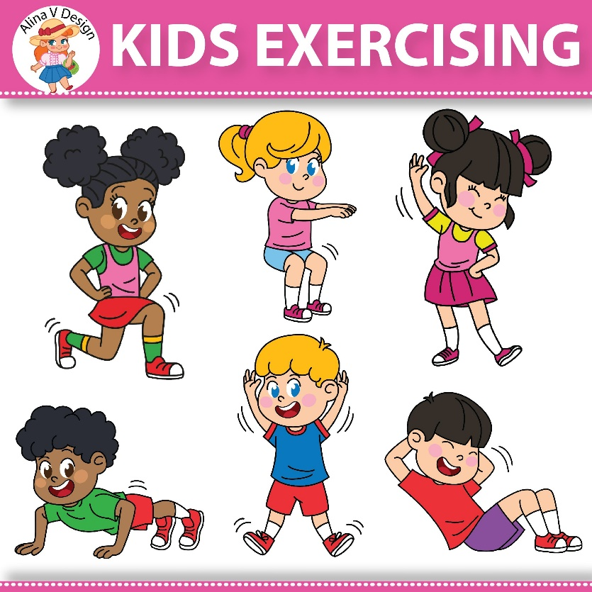](https://www.google.co.uk/url?sa=i&url=https%3A%2F%2Fwebstockreview.net%2Fexplore%2Fchildren-clipart-exercise%2F&psig=AOvVaw1XkielYFpvuo3FQCKG37RP&ust=1586517596074000&source=images&cd=vfe&ved=0CAIQjRxqFwoTCMDi0eCc2-gCFQAAAAAdAAAAABAL)

**Maths with Carol Vorderman**

<https://www.themathsfactor.com/>

**Music with Myleene Klass**

<https://www.youtube.com/channel/UCQh2wgJ5tOrixYBn6jFXsXQ>

[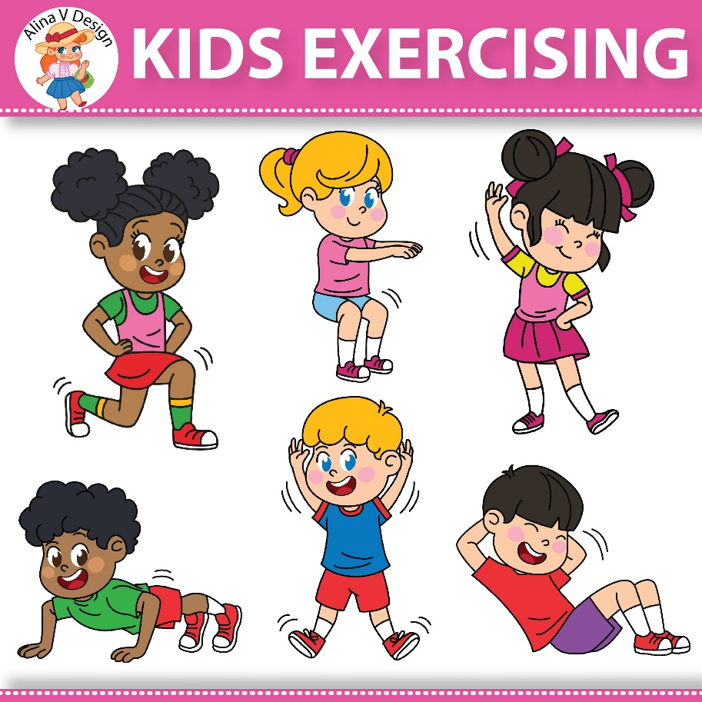](https://www.google.co.uk/url?sa=i&url=https%3A%2F%2Fwebstockreview.net%2Fexplore%2Fchildren-clipart-exercise%2F&psig=AOvVaw1XkielYFpvuo3FQCKG37RP&ust=1586517596074000&source=images&cd=vfe&ved=0CAIQjRxqFwoTCMDi0eCc2-gCFQAAAAAdAAAAABAL)

**PE with Joe Wicks**

<https://www.thebodycoach.com/blog/pe-with-joe-1254.html>

**Reading with David Walliams**

<https://www.worldofdavidwalliams.com/>

**Science with Maddie Moate** <https://www.youtube.com/results?search_query=science+with+maddie+moate>

Virtual trips and activity ideas

Virtual trips are a great way to expose children to new places. Many museums, zoos and aquariums have set up virtual tours of their facilities. Below are some ideas of virtual trips you can take with your children. There are also suggested activities to extend the learning for each type of destination.

Art Museums

* Louvre Museum, Paris. <https://www.louvre.fr/en/visites-en-ligne>
* National Gallery of Art, Washington DC. <https://www.nga.gov/features/degas-virtual-tour.html>
* Van Gogh Museum, Amsterdam. <https://artsandculture.google.com/partner/van-gogh-museum?hl=en>

**Activities:**

1. Choose a favourite painting or sculpture and create a copycat piece of art
2. Research an artist.
3. Choose a piece of art to focus on. Describe it, tell why you chose it and how it makes you feel.
4. [](https://www.google.co.uk/url?sa=i&url=https%3A%2F%2Fwww.vectorstock.com%2Froyalty-free-vector%2Fcartoon-of-ancient-egyptian-pharaoh-vector-20469645&psig=AOvVaw266Z3rFBQbwuNd70lYqDqf&ust=1586517449323000&source=images&cd=vfe&ved=0CAIQjRxqFwoTCOC3lZuc2-gCFQAAAAAdAAAAABAD)Choose 2 works of art to compare.

History Museums

* The British Museum. <https://britishmuseum.withgoogle.com/>
* Discover Ancient Egypt. <https://discoveringegypt.com/>
* Smithsonian National Museum of Natural History. <https://naturalhistory2.si.edu/vt3/NMNH/z_tour-022.html>

**Activities:**

1. Write your own exhibit labels to help people who are younger than you understand and learn.
2. Take turns being the museum guide. The guide who is in turn chooses the work or object he or she wants to talk about.
3. Choose an artefact and write a story about it.
4. Choose an artefact and consider how it might have changed and evolved over time. How does it compare to the present day?

Animals and Nature

* San Deigo Zoo. <https://kids.sandiegozoo.org/activities>
* Seattle Aquarium. <https://www.youtube.com/watch?v=mY8__n13tKM&feature=youtu.be>
* Nature Lab. <https://www.nature.org/en-us/about-us/who-we-are/how-we-work/youth-engagement/nature-lab/virtual-field-trips/>

**Activities:**

1. Do more research on your favourite animal and make a leaflet or presentation.
2. Research the habitat of different animals. Use home materials to create a mini habitat.
3. Make a poster advertising the zoo/aquarium to families and draw a map of the facility.
4. Write a persuasive letter or brochure encouraging people to donate money to help protect endangered species.